Lab 5

Brandon P Trinkle

Arizona State University

Course Number: IFT 220

Professor Betty J. Lauer

April 11, 2024

Lab 4

DC01: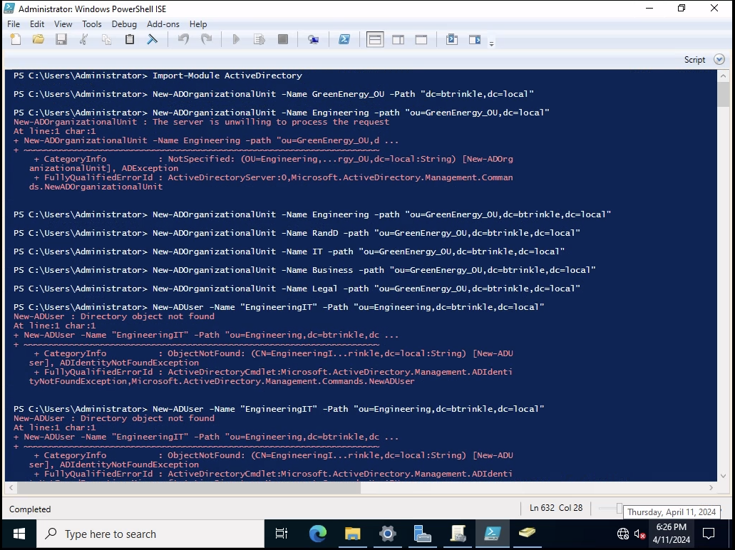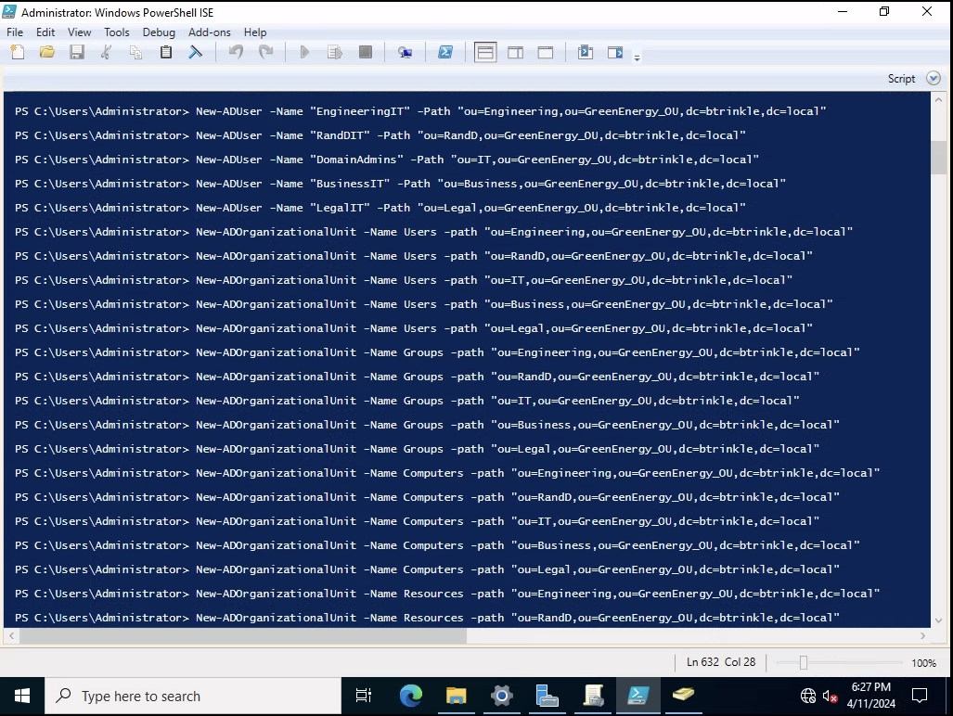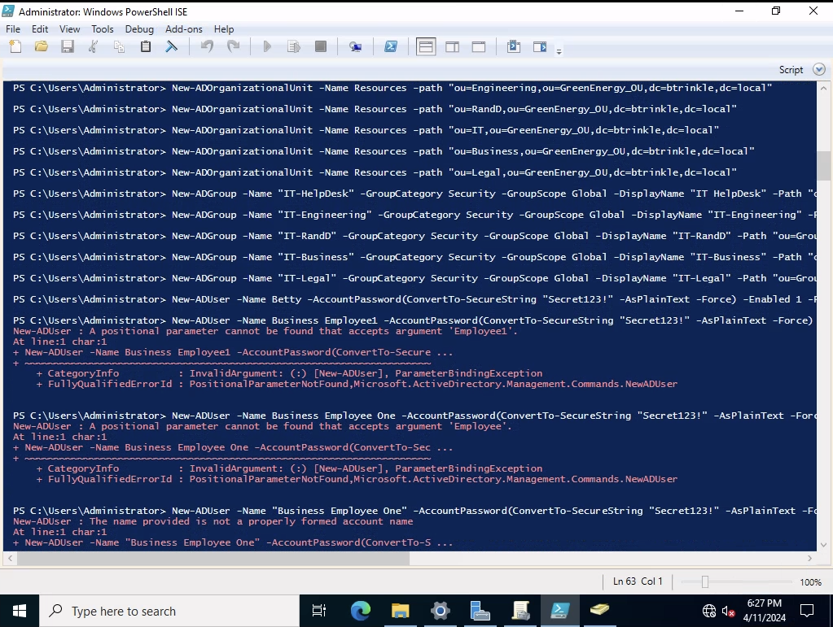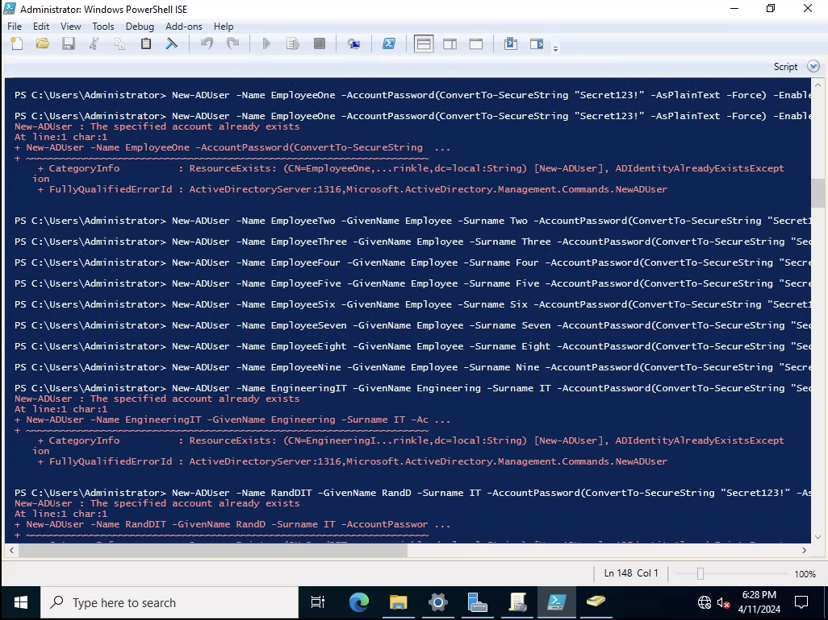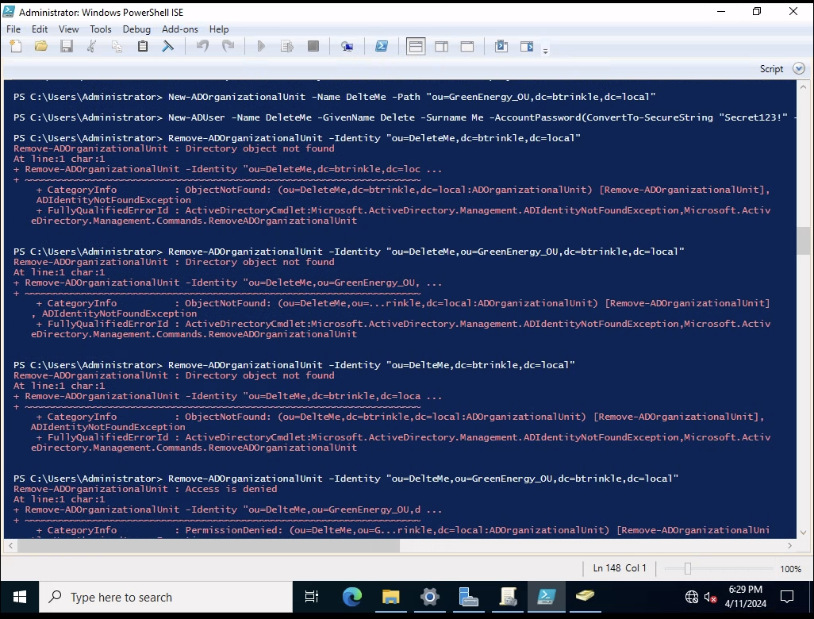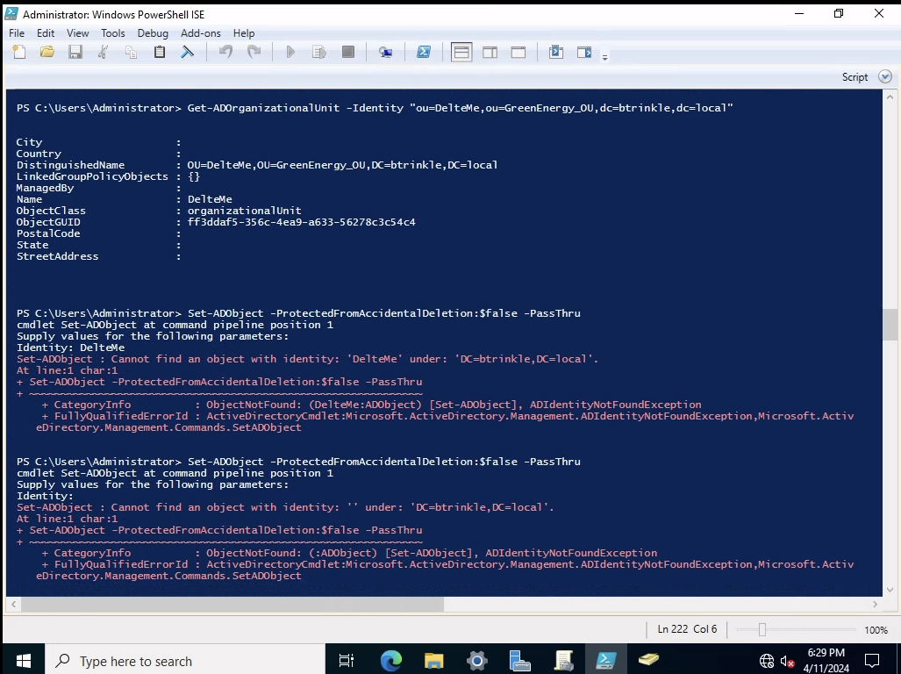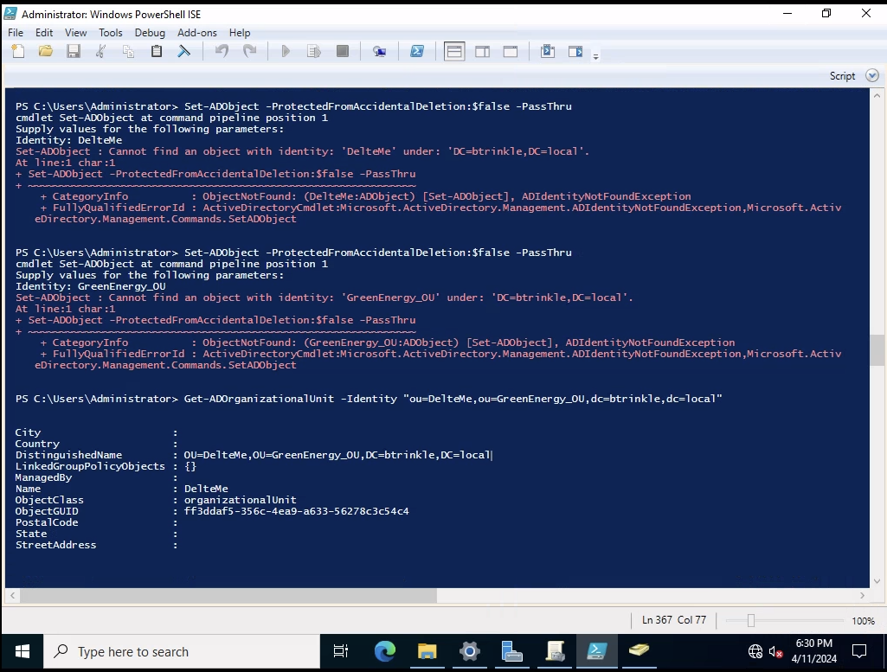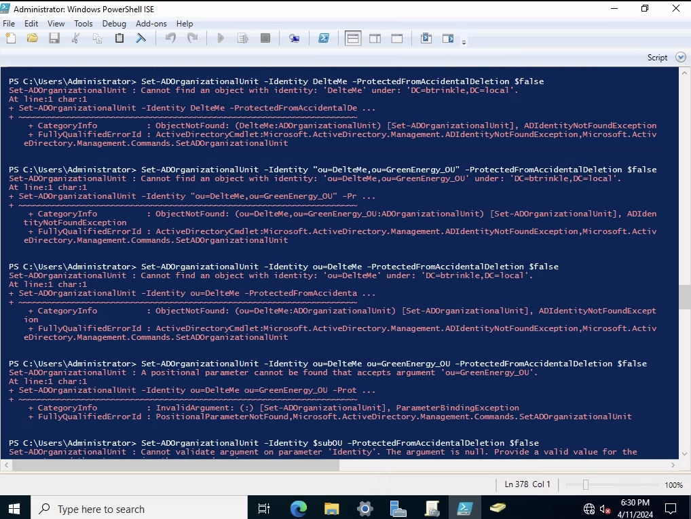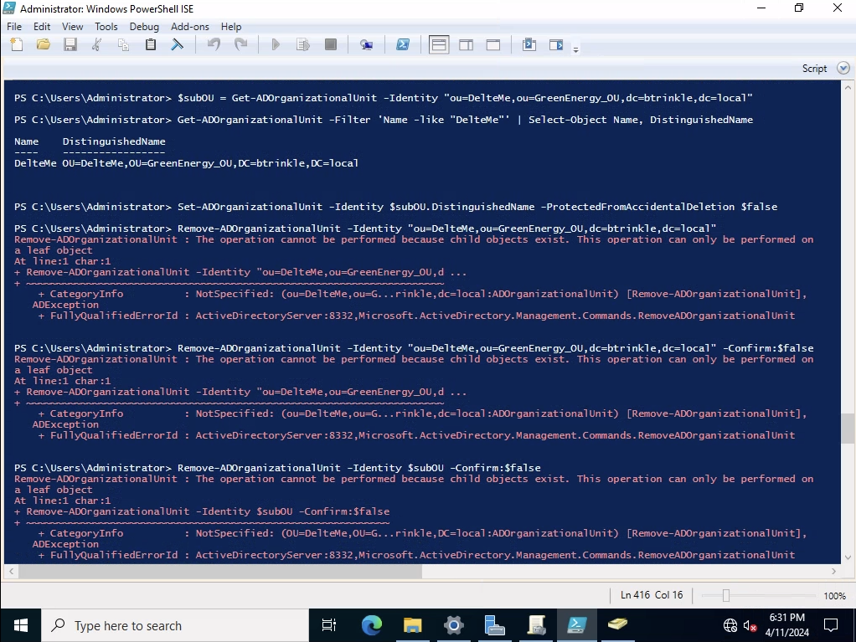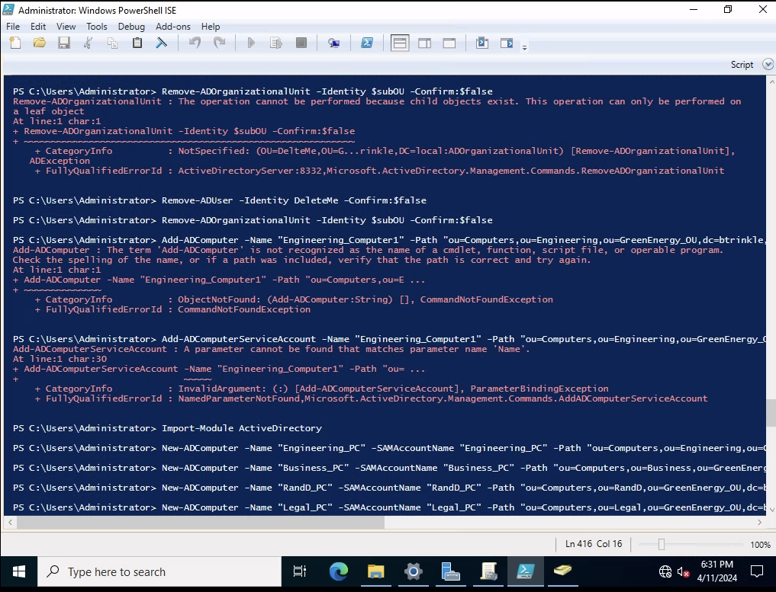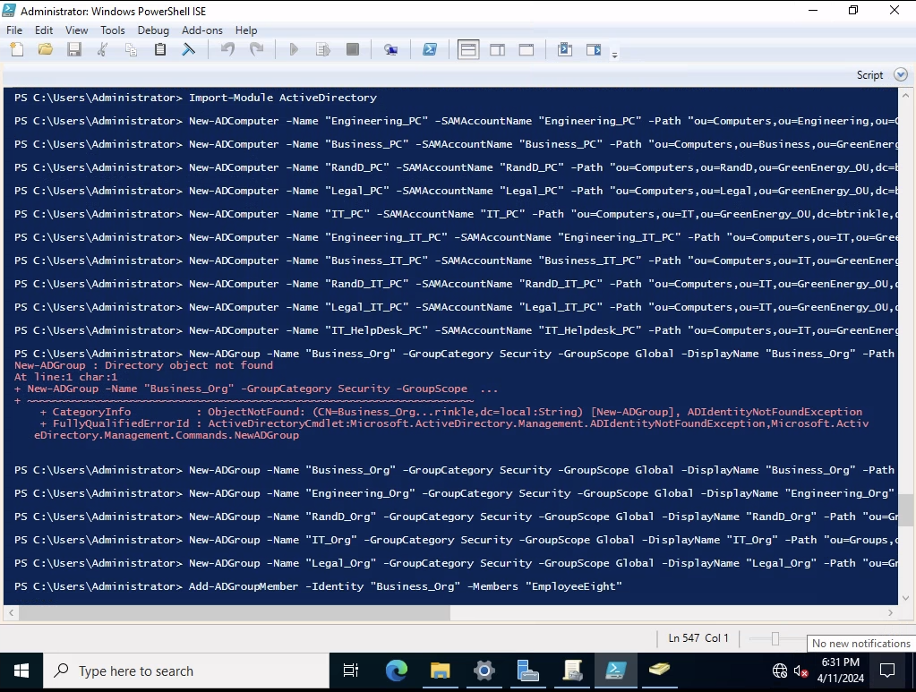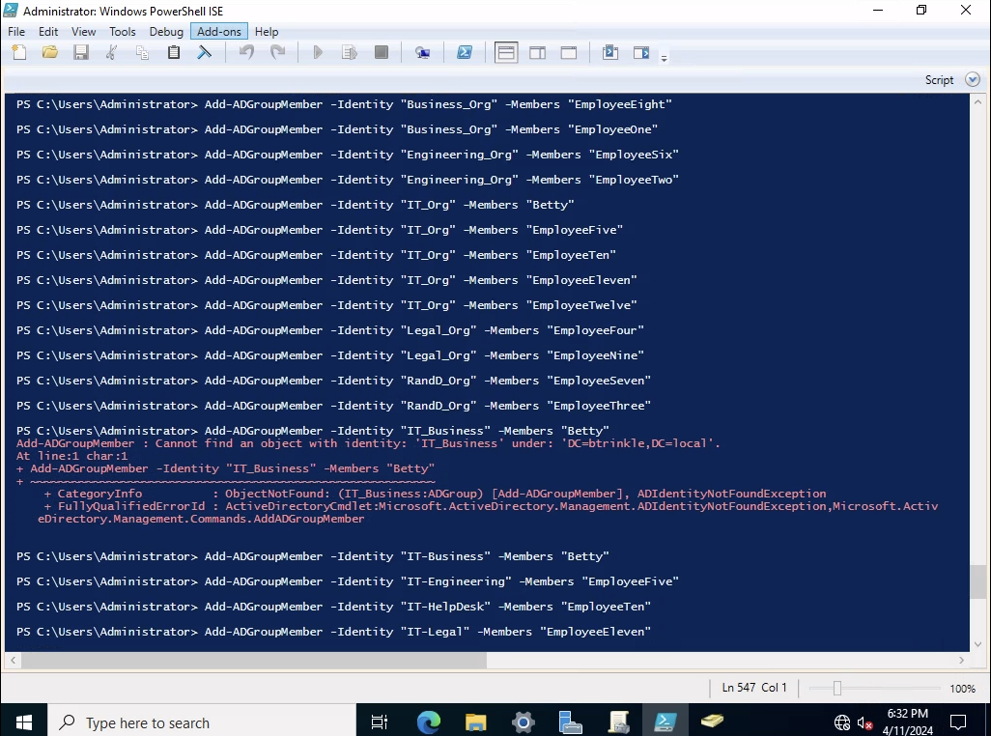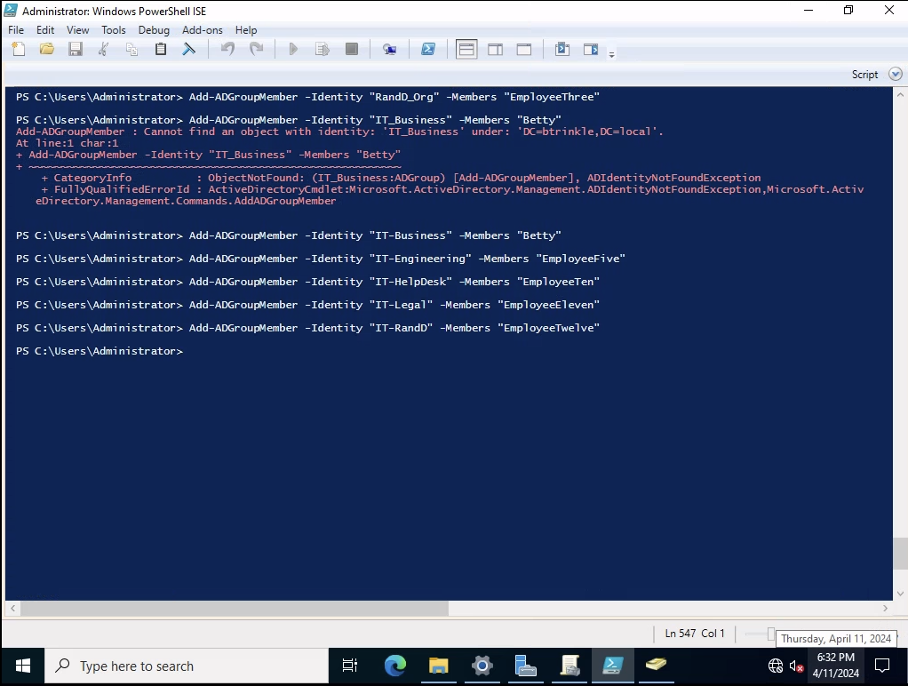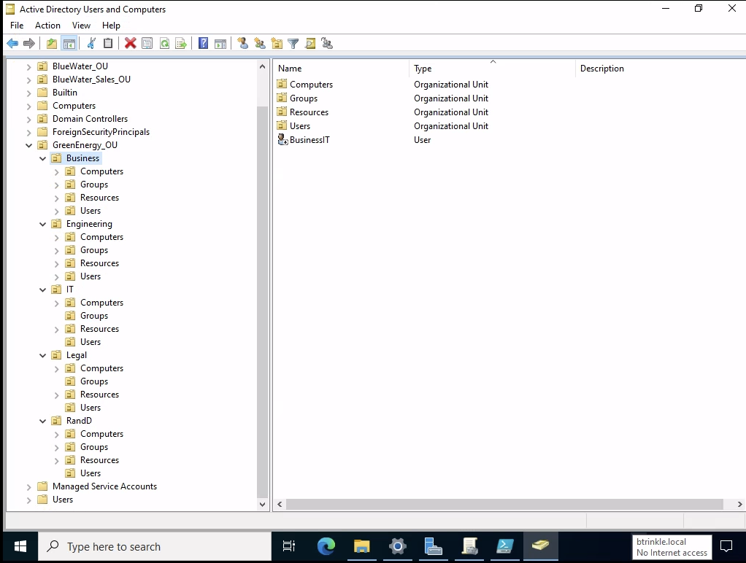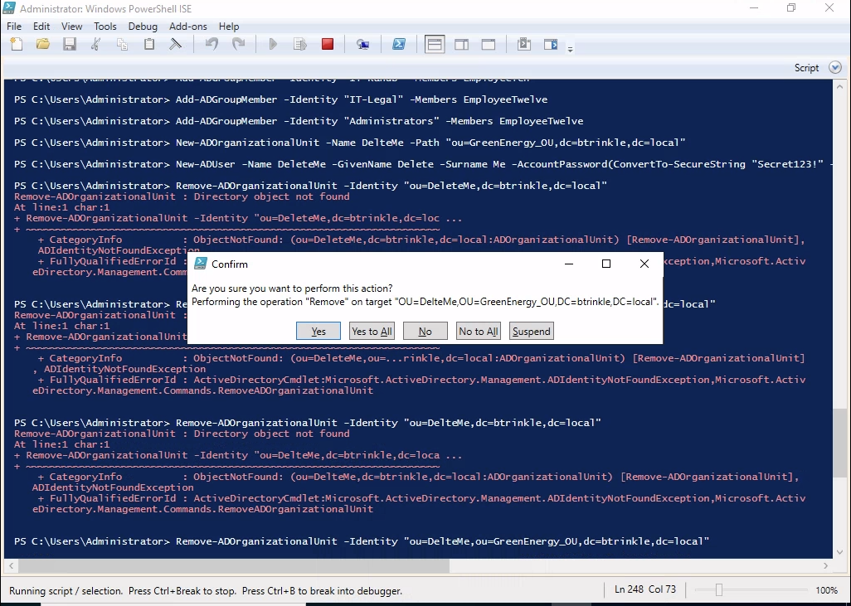

**Summary:**

Lab 5 provided a wonderful experience in designing and managing an IT infrastructure for the fictional Green Energy Battery Company using PowerShell. This practical assignment aimed to replicate the company’s organizational structure within an IT system, creating a clear and manageable digital framework that mirrored the physical organization.

One of the main outcomes of the project was the development of a structured IT environment that closely followed the company’s organizational chart. By creating organizational units for each department such as Engineering, Research and Development, Business, and Legal, I organized the digital workspace to reflect the company’s hierarchy. This structuring allows for easier management and navigation, ensuring that user setups, permissions, and resources are logically grouped and easier to oversee. Using PowerShell, I significantly enhanced my ability to write and execute scripts that automate and streamline tasks within the IT environment. The project involved using PowerShell to set up new user accounts, configure access permissions, and manage department-specific settings. By automating these tasks, I improved efficiency and reduced the potential for human error, leading to a more reliable IT system setup.

Another important outcome was learning how to securely manage access within the IT environment. By setting up separate access rights for different teams and establishing a helpdesk with specific permissions, I ensured that sensitive areas of the IT system were protected against unauthorized access while still allowing sufficient accessibility for user management and IT support tasks. This balance is critical in maintaining both security and functionality within a business IT environment. Throughout the project, troubleshooting script errors and configuration issues provided practical problem-solving experience. This not only sharpened my technical troubleshooting skills but also improved my resilience and attention to detail in IT practice. Dealing with these challenges in a controlled learning environment prepared me for managing similar issues in a real-world setting, where efficient problem resolution is crucial.

In summary, the project was instrumental in bridging theoretical knowledge with practical application in IT management using PowerShell. It enhanced my technical proficiency, particularly in scripting and system administration, and provided a deep dive into strategic IT planning. These skills are essential for any IT professional and will be valuable skills in my future career, especially in roles that involve managing and safeguarding digital environments. The hands-on experience not only improved my understanding of how IT systems function and are managed but also boosted my confidence in using advanced tools to create and manage secure, efficient IT infrastructures.